MINI PROJECT

(SESSION-2020-2021)

Report



**Institute of Engineering & Technology**

**Team Members**

**SHUBHANGI SRIVASTAVA**

**(181500704)**

**AYUSHI AGRAWAL**

**(181500182)**

**KISHORI AGRAWAL**

**(181500326)**

## Supervised By

**MR.MANDEEP SINGH**

**TECHNICAL TRAINER**

**Department of Computer Engineering &Websites**



**Department of Computer Engineering and Applications**

**GLA University, Mathura**

**17 km. Stone NH#2, Mathura-Delhi Road, P.O. – Chaumuha,**

**Mathura – 281406**

**Declaration**

I hereby declare that the work which is being presented in the Mini Project **“E-commerce: Curated Shopping cart”,** in partial fulfillment of the requirements for Mini project Lab is an authentic record of our own work carried under the supervision of **Mr.** **Mandeep Singh, Technical Trainer.**

**SHUBHANGI SRIVASTAVA**

**AYUSHI AGRAWAL**

**KISHORI AGRAWAL**



**Department of Computer Engineering and Applications**

**GLA University, Mathura**

**17 km. Stone NH#2, Mathura-Delhi Road, P.O. – Chaumuha,**

**Mathura – 281406**

**Certificate**

This is to certify that the project entitled “E-commerce: Curated Shopping cart”, carried out in Mini Project – I Il Lab is abonafide work done by SHUBHANGI SRIVASTAVA(181500704), AYUSHIAGRAWAL(181500182), KISHORI AGRAWAL(181500326)and is submitted in partialfulfillment of the requirements for the award of the degree Bachelor of Technology (ComputerScience & Engineering).

**Signature of Supervisor:**

**Name of Supervisor: Mr. Mandeep Singh**





**ACKNOWLEDGEMENT**

We take this opportunity to thank all those who have helped us in completing the

project successfully.

It gives us a great sense of pleasure to present the report of the B. Tech Mini Project undertaken during B. Tech. Third Year. This project in itself is an acknowledgement to the inspiration, drive and technical assistance contributed to it by many individuals. This project would never have seen the light of the day without the help and guidance that we have received.

Our heartiest thanks to Dr. (Prof). Anand Singh Jalal, Head of Dept., Department of CEA for providing us with an encouraging platform to develop this project, which thus helped us in shaping our abilities towards a constructive goal.

We owe special debt of gratitude to Mr. Mandeep Singh, Technical Trainer, for his constant support and guidance throughout the course of our work. His sincerity, thoroughness and perseverance have been a constant source of inspiration for us. He has showered us with all his extensively experienced ideas and insightful comments at virtually all stages of the project & has also taught us about the latest industry-oriented technologies.

We also do not like to miss the opportunity to acknowledge the contribution of all faculty members of the department for their kind guidance and cooperation during the development of our project. Last but not the least, we acknowledge our friends for their contribution in the completion of the project.

**ABSTRACT**

The main purpose of this project is to create an Online product selling Website that allows users to buy item based on price, quantity and its authenticity. The selected items are displayed in an attractive format and the buyer can simply buy those items white sitting at home. The Administrator will have additional functionalities when compared to the common user. Another objective of this project is to promote local manufacturers; small businessman can contact us to get their products on display so as to get them on the mainstream online market.

This project is an attempt to provide the advantages of online shopping to customers of a real shop. It helps buying the products in the shop anywhere through internet by using an android device. Thus, the customer will get the service of online shopping and home delivery from his favorite shop. This system can be implemented to any shop in the locality or to multinational branded shops having retail outlet chains. If shops are providing an online portal where their customers can enjoy easy shopping from anywhere, the shops won’t be losing any more customers to the trending online shops such as flipcart or eBay. Since the application is available in the Smartphone it is easily accessible and always available.

**Table of Contents**

|  |  |
| --- | --- |
| Declaration | ii |
| Certificate | iii |
| Acknowledgments | vii |
| Abstract | viii |
| Table of Contents | ix |
| 1. **Introduction** | **1** |
| 1.1 Motivation and Overview | 1 |
| 1.2 Objective | 2 |
| 1. **Software Requirement Analysis** | **3** |
| 2.1 Define the problem ………………………………………………….. | 3 |
| 2.2 Define the modules and their functionalities (SRS) ……………..………………………………… | 4 |
| 1. **Software Design** | **9** |
|  | 16 |
| 3.2 ……………………..…………………. |  |
| 1. **Testing** | **12** |
| 4.1 ………….……………………………………… | 22 |
| 4.2 ……………………..…………………. | 22 |
| 1. **Implementation and User Interface** | **13** |
|  |  |
| **6.References/Bibliography** | **33** |

Chaper-1

**INTRODUCTION AND OVERVIEW**

In today’s fast-changing business environment, we have proposed a curated E-Commerce shopping cart that revolves around party supplies, available all at one place, all year long at a click and entitled it as ‘Confetti Cart’. In order to develop it, a number of technologies have been studied and understood. These include prominent front end and back end technologies. This is a project with the objective to develop a basic website where a consumer is provided with a shopping cart application and also to know about the technologies used to develop such an application that provides instant access to diverse party related products or services.

A good shopping cart design must be accompanied with user-friendly shopping cart application logic. It should be convenient for the customer to view the contents of their cart and to be able to remove or add items to their cart. The shopping cart application described in this project fulfills all the above requirements and provides a number of features that are designed to make the customer more comfortable.

In a sense, the Covid-19 pandemic has changed the way we work, shop and communicate with people more than any other disruption (including technological ones) in the recent past. As more people have started working from home, they are sticking to basics, stepping outside only to buy essentials and are constantly worried about the risks of getting infected in crowded places like malls and supermarkets. Even on special occasions people can’t step out of their houses for party preps, so we have taken an initiative to facilitate them with all the party kindred supplies that they require at their doorstep in a hygiene nurtured platform. The Confetti Cart also eliminates the time wasted by the customers on surfing, as it takes a lot of time to switch between various shopping sites to get all the party supplies that they desire.

Hence, it provides everything encircling parties at one stop.

**OBJECTIVE**

It’s extremely important to be able to respond to client needs in the most effective and timely manner whenever the customer have a yen to see our business online and ought to have instant access to our products. Hence, the idea of this project intends to ensure customer satisfaction during the harsh circumstances and to make sure that they do not lack in any aspect on their indelible vivid day.

The *Confetti Cart* also eliminates the time wasted by the customers on surfing, as it takes a lot of time to switch between various shopping sites to get all the party supplies that they desire. Hence, it provides everything encircling parties at one stop.

CHAPTER-2

**PROBLEM STATEMENT**

Many-a-times, we have seen that people want to buy products but due to some reasons cannot go physically to the shops to buy them. And since this is a pandemic going on so people really prefer to have the stuff delivered rather than going to the shop. Similarly, the small businesses are having problem in sales due to this pandemic. So, this E-Shopping website will act as a bridge between the stuck at home public and their urge to shop as well as a helping hand towards the local businesses to expand their reach to the online platforms as well.

**DEFINITIONS**

**ABOUT FRONT-END TECHNOLOGY:**

The front-end stack is made up of many different languages and libraries. While these vary from application to application, there are only a few generic languages understood by all web browsers. These three main front-end coding languages are HTML, CSS and JavaScript.

Together, they create the underlying scaffolding that web browsers use to render the web pages that we interact with every day. All other libraries and front-end engineering are built upon these three main languages, which makes them must-have skills for any front-end developer.

In fact, you can think of a webpage like a house. The initial UX design is the blueprint. HTML is the basic structure of the house. The CSS is the paint, fixtures, and other aesthetic decisions that make the house look attractive. And finally, JavaScript is the inner workings of the house (lights, heating, water) that we, the owner or renter, use and enjoy.

**VISUAL STUDIO:**

Visual Studio Code is a source-code editor that can be used with a variety of programming languages, including  [Java](https://en.wikipedia.org/wiki/Java_(programming_language)), [JavaScript](https://en.wikipedia.org/wiki/JavaScript), [Go](https://en.wikipedia.org/wiki/Go_(programming_language)), [Node.js](https://en.wikipedia.org/wiki/Node.js) and [C++](https://en.wikipedia.org/wiki/C%2B%2B). It is based on the [Electron](https://en.wikipedia.org/wiki/Electron_(software_framework)) framework, which is used to develop [Node.js](https://en.wikipedia.org/wiki/Node.js) [Web applications](https://en.wikipedia.org/wiki/Web_application) that run on the [Blink layout engine](https://en.wikipedia.org/wiki/Blink_layout_engine). Visual Studio Code employs the same editor component (codenamed "Monaco") used in [Azure DevOps](https://en.wikipedia.org/wiki/Azure_DevOps_Server) (formerly called Visual Studio Online and Visual Studio Team Services).

Instead of a project system, it allows users to open one or more directories, which can then be saved in workspaces for future reuse. This allows it to operate as a [language-agnostic](https://en.wikipedia.org/wiki/Language-agnostic) code editor for any language. It supports a number of programming languages and a set of features that differs per language. Unwanted files and folders can be excluded from the project tree via the settings. Many Visual Studio Code features are not exposed through menus or the user interface, but can be accessed via the command palette.

Visual Studio Code can be extended via [extensions](https://en.wikipedia.org/wiki/Plug-in_(computing)), available through a central repository. This includes additions to the editor and language support. A notable feature is the ability to create extensions that add support for new [languages](https://en.wikipedia.org/wiki/Programming_language), [themes](https://en.wikipedia.org/wiki/Theme_(computing)), and [debuggers](https://en.wikipedia.org/wiki/Debugger), perform [static code analysis](https://en.wikipedia.org/wiki/Static_code_analysis), and add [code linters](https://en.wikipedia.org/wiki/Lint_(software)) using the [Language Server Protocol](https://en.wikipedia.org/wiki/Language_Server_Protocol).

Visual Studio Code includes multiple extensions for FTP, allowing the software to be used as a free alternative for web development. Code can be synced between the editor and the server, without downloading any extra software.

Visual Studio Code allows users to set the [code page](https://en.wikipedia.org/wiki/Code_page) in which the active document is saved, the [newline](https://en.wikipedia.org/wiki/Newline) character, and the programming language of the active document. This allows it to be used on any platform, in any locale, and for any given programming language.

**WEB BROWSER:**

A web browser (commonly referred to as a browser) is a [software application](https://en.wikipedia.org/wiki/Software_application) for accessing information on the [World Wide Web](https://en.wikipedia.org/wiki/World_Wide_Web). Each individual [web page](https://en.wikipedia.org/wiki/Web_page), image, and video is identified by a distinct [Uniform Resource Locator](https://en.wikipedia.org/wiki/URL) (URL), enabling browsers to retrieve these resources from a [web server](https://en.wikipedia.org/wiki/Web_server) and display them on the [user](https://en.wikipedia.org/wiki/User_(computing))'s device.

A web browser is not the same thing as a [search engine](https://en.wikipedia.org/wiki/Web_search_engine), though the two are often confused. For a user, a search engine is just a [website](https://en.wikipedia.org/wiki/Website), such as [google.com](https://en.wikipedia.org/wiki/Google_Search), that stores searchable data about other websites. But to connect to a website's server and display its web pages, a user needs to have a web browser installed on their device.

The most popular browsers are [Chrome](https://en.wikipedia.org/wiki/Google_Chrome), [Firefox](https://en.wikipedia.org/wiki/Firefox), [Safari](https://en.wikipedia.org/wiki/Safari_(web_browser)), [Internet Explorer](https://en.wikipedia.org/wiki/Internet_Explorer), and [Edge](https://en.wikipedia.org/wiki/Microsoft_Edge).

**Technical Feasibility:**

The proposed system is developed using HTML, CSS and bootstrap as front-end tool and php and js node as the back end. The proposed system needs a Personal Web Server to serve the requests submitted by the users. The Web browser is used to view the web page that is available within the Windows operating system itself. The proposed system will run under Win9x, NT, and win2000 environment. As Windows is very user friendly and GUI OS it is very easy to use. All the required hardware and software are readily available in the market. Hence the system is technically feasible.

**Operational Feasibility:**

The proposed system is operationally feasible because of the following reasons.

• The customer is benefited more as most of his time is saved. The customer is serviced at his place of work.

• The purpose of this website serves the good and needy people.

**Economical Feasibility:**

As the necessary hardware and software are available in the market at a low cost, the initial investment is the only cost incurred and does not need any further enhancements. Hence it is economically feasible. The system is feasible in all respects and hence it encourages taking up the system design. We have used different languages and technologies for preparing the project.

**LANGUAGES USED:**

1. **HTML**:

HTML stands for Hyper Text Mark-up Language. It is used to design web pages using mark-up language. HTML is the combination of Hypertext and Mark-up language. Hypertext defines the link between the web pages. Mark-up language is used to define the text document within tag which defines the structure of web pages.

HTML can embed programs written in a [scripting language](https://en.wikipedia.org/wiki/Scripting_language) such as [JavaScript](https://en.wikipedia.org/wiki/JavaScript), which affects the behavior and content of web pages. Inclusion of CSS defines the look and layout of content. The [World Wide Web Consortium](https://en.wikipedia.org/wiki/World_Wide_Web_Consortium) (W3C), maintainer of both the HTML and the CSS standards, has encouraged the use of CSS over explicit presentational HTML since 1997.

HTML code ensures the proper formatting of text and images so that your [Internet browser](https://www.computerhope.com/jargon/b/browser.htm)may display them as they are intended to look. Without HTML, a browser would not know how to display text as [elements](https://www.computerhope.com/jargon/h/html-element.htm) or load images or other elements. HTML also provides a basic structure of the page, upon which [Cascading Style Sheets](https://www.computerhope.com/jargon/c/css.htm) are overlaid to change its appearance. One could think of HTML as the bones (structure) of a web page, and CSS as its skin (appearance).

2. **CSS**:

Cascading Style Sheets, fondly referred to as CSS, is a simply designed language intended to simplify the process of making web pages presentable. CSS allows you to apply styles to web pages. More importantly, CSS enables you to do this independent of the HTML that makes up each web page.

CSS handles the look and feel part of a web page. Using CSS, you can control the color of the text, the style of fonts, the spacing between paragraphs, how columns are sized and laid out, what background images or colors are used, layout designs, variations in display for different devices and screen sizes as well as a variety of other effects.

3. **Bootstrap** 4:

Bootstrap is a free and open-source tool collection for creating responsive websites and web applications. It is the most popular HTML, CSS, and JavaScript framework for developing responsive, mobile-first web sites. It solves many problems which we had once, one of which is the cross-browser compatibility issue. . In addition, developers can take advantage of CSS classes defined in Bootstrap to further customize the appearance of their contents. For example, Bootstrap has provisioned for light- and dark colored tables, page headings, more prominent pull quotes, and text with a highlight. Bootstrap also comes with several JavaScript components in the form of jQuery plugins. They provide additional user interface elements such as dialog boxes, tooltips, and carousels. Each Bootstrap component consists of an HTML structure, CSS declarations, and in some cases accompanying JavaScript code. They also extend the functionality of some existing interface elements, including for example an auto-complete function for input fields.

## Getting Started with Bootstrap Basics

Bootstrap is available in two forms; as a precompiled version, and as a source code version. The source code version uses the [Less](http://lesscss.org/) CSS preprocessor, but if you are more into Sass, there is an [official Sass port of Bootstrap](https://github.com/twbs/bootstrap-sass) also available. To make it easier to make use of CSS vendor prefixes, Bootstrap uses [Autoprefixer](https://github.com/postcss/autoprefixer).

The source code version comes styles source code written in Less (or Sass), all the JavaScript, and accompanying documentation. This allows more ambitious designers and developers to change and customize, at their will, all the provided styles, and to build their own version of Bootstrap.

4. **JavaScript**:

JavaScript is a lightweight, interpreted programming language. It is designed for creating network-centric applications. It is complimentary to and integrated with Java. JavaScript is very easy to implement because it is integrated with HTML. It is open and cross platform. JavaScript is the most popular programming language in the world and that makes it a programmer’s great choice. Once you learnt JavaScript, it helps you developing great frontend as well as back-end software using different JavaScript based frameworks like jQuery, Node.JS etc.

As a multi-paradigm language, JavaScript supports [event-driven](https://en.wikipedia.org/wiki/Event-driven_programming), [functional](https://en.wikipedia.org/wiki/Functional_programming), and [imperative](https://en.wikipedia.org/wiki/Imperative_programming) (including [object-oriented](https://en.wikipedia.org/wiki/Object-oriented_programming) and [prototype-based](https://en.wikipedia.org/wiki/Prototype-based_programming)) [programming styles](https://en.wikipedia.org/wiki/Programming_paradigm). It has [APIs](https://en.wikipedia.org/wiki/Application_programming_interface) for working with text, [arrays](https://en.wikipedia.org/wiki/Array_data_type), dates, [regular expressions](https://en.wikipedia.org/wiki/Regular_expression), and the [DOM](https://en.wikipedia.org/wiki/Document_Object_Model), but the language itself does not include any [I/O](https://en.wikipedia.org/wiki/Input/output), such as [networking](https://en.wikipedia.org/wiki/Computer_network), [storage](https://en.wikipedia.org/wiki/Data_storage), or [graphics](https://en.wikipedia.org/wiki/Computer_graphics) facilities. It relies upon the host environment in which it is embedded to provide these features.

Initially only implemented [client-side](https://en.wikipedia.org/wiki/Client-side) in web browsers, JavaScript engines are now embedded in many other types of host software, including [server-side](https://en.wikipedia.org/wiki/Server-side) in web servers and databases, and in non-web programs such as word processors and [PDF](https://en.wikipedia.org/wiki/Portable_Document_Format) software, and in runtime environments that make JavaScript available for writing mobile and desktop applications, including desktop widgets.

**REQUIREMENTS:**

**Software Specification:**

• Technology Implemented : Front-end, Back-end Technology

• Tools Used : Html, css, javascript, Bootstrap

• User Interface Design : Visual Studio(Version 1.48)

**Hardware Requirements:**

• Processor : intel i3

• Operating System : Windows 10

• RAM : 8GB

• Hardware Devices : Computer System

• Hard disk : 1 TB

**Chapter-3**

**SOFTWARE DESIGN**

**Preliminary Design:**Preliminary design is basically concerned with deriving an overall picture of the system. Deriving entire system into modules and sub-modules while keeping Cohesion and Coupling factors in mind. Tools, which assist in preliminary design process, are Data Flow Diagrams.

**Code design:**The purpose of code is to facilitate the identification and retrieval for items of information. A code is an ordered collection of symbols designed to provide unique identification of an entity or attribute. To achieve unique identification there must be only one place where the identified entity or the attribute can be entered in the code; conversely there must be a place in the code for everything that is to be identified. This mutually exclusive feature must be built into any coding system. The codes for this system are designed with two features in mind. Optimum human oriented use and machine efficiency. Length of the code range from length of one to length of five characteristics:

* The code structure is unique; ensuring that only one value of the code with a single meaning may be correctly applied to a given entity or attributes.
* The code structure is expansible allowing for growth of its set of entities and attributes.
* The code is concise and brief for recording, communication, transmission and storage efficiencies.
* They have a uniform size and format.
* The codes are simple so that the user can easily understand it.
* The codes are also versatile i.e., it is easy to modify to reflect necessary changers in condition, chart eristic and relationships of the encode entities.
* The codes are also easily storable for producing reports in a predetermined order of format.
* The codes are also stable and do not require being frequently updated thereby promoting user efficiency.
* The codes are also meaningful.
* They are also operable i.e, they are adequate for present and anticipate data processing both for machine and human use.

**PROCESS**

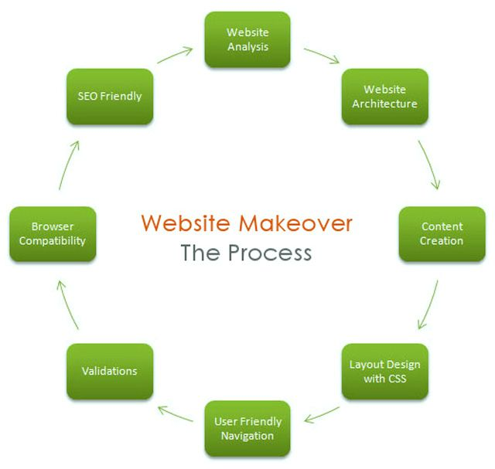

**SOFTWARE TESTING**

# Testing is a process of executing a program with the intent of finding an error. Testing is a crucial element of software quality assurance and presents ultimate review of specification, design and coding. System Testing is an important phase. Testing represents an interesting anomaly for the software. A good test case is one that has a high probability of finding an as undiscovered error.

The test approach is divided into three main phases:

Module testing, integration testing and system testing.

In addition, the system testing includes two sub-phases: functional and usability testing. These planned tests are explained briefly below.

(a) Module testing will perform during coding by using debug messages to check that the written code produces wanted results. An important requirement is that the code will compile with zero bugs.

(b) Integration testing will perform after finish module testing in order to validate if each module can work fine with each other. Integration Test proves that system works as integrated unit when all the fixes are complete.

(c) System testing includes two phases: functional testing and usability testing. These will perform after the product reaches its final version. During functional test phase, the tester will test if the product meets the game requirements. The tester tests the requirements using the use cases listed below in Test Cases section. The usability test will perform to understand how easy it is to use this restaurant website. Any person out of the team members will perform this test by selecting the category and placing the order via call.

**SCREENSHOTS Of WEBSITE-**

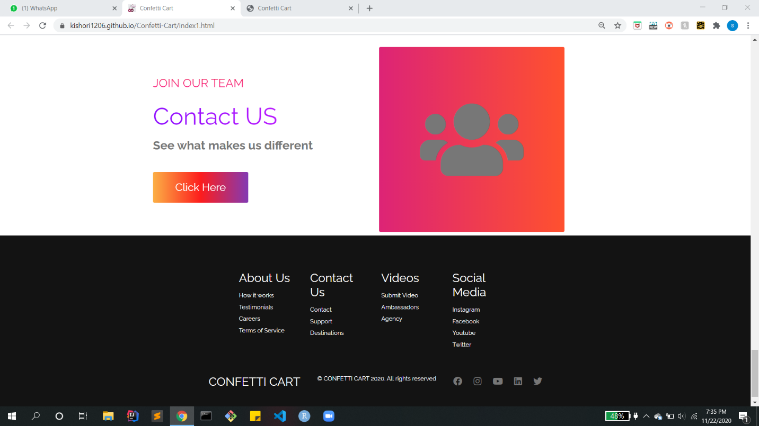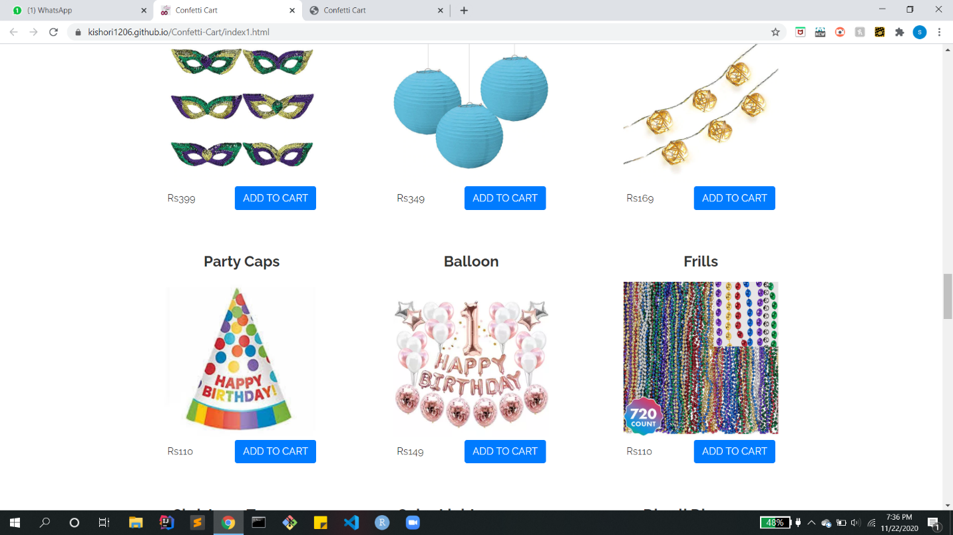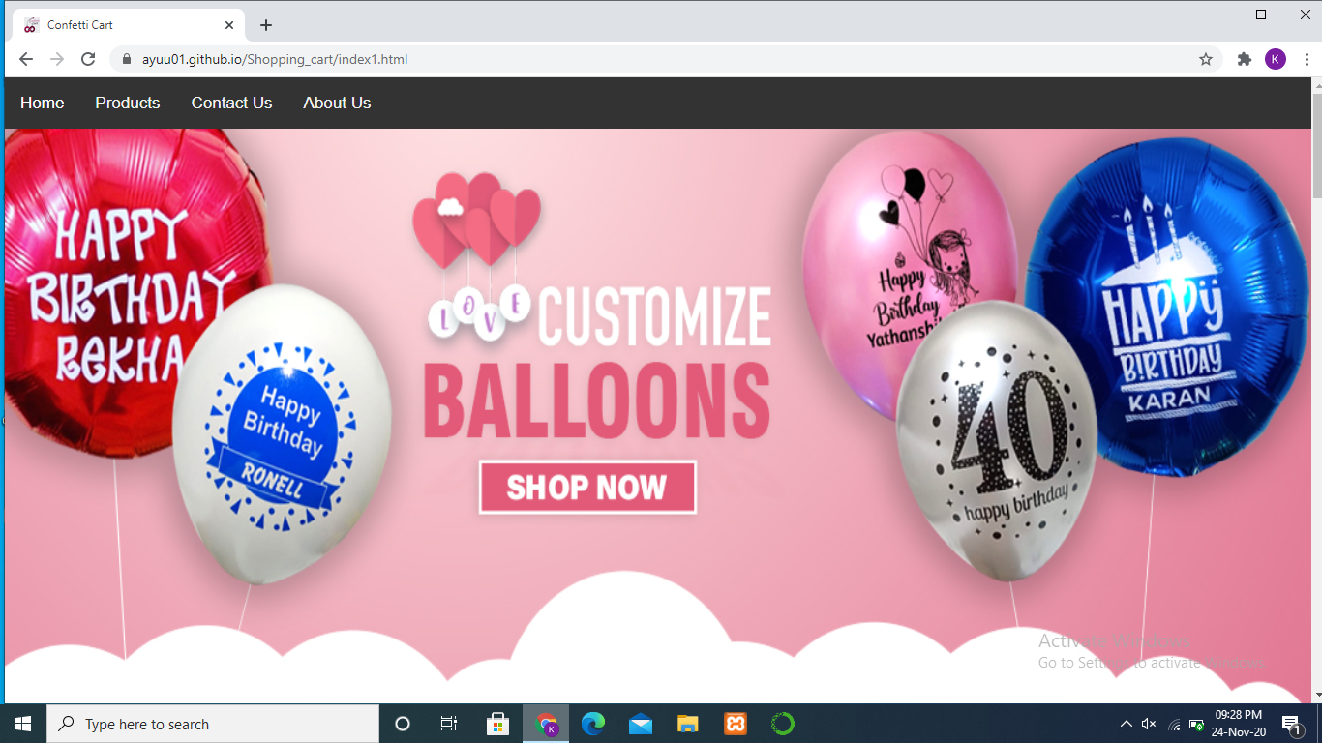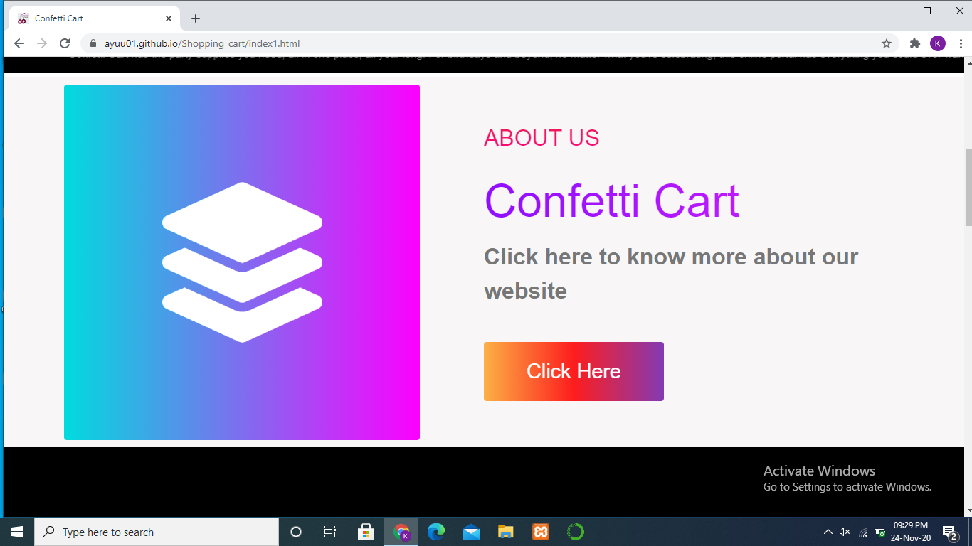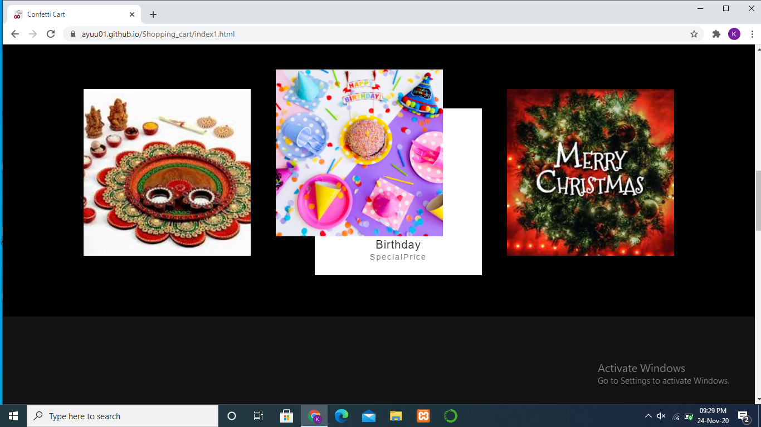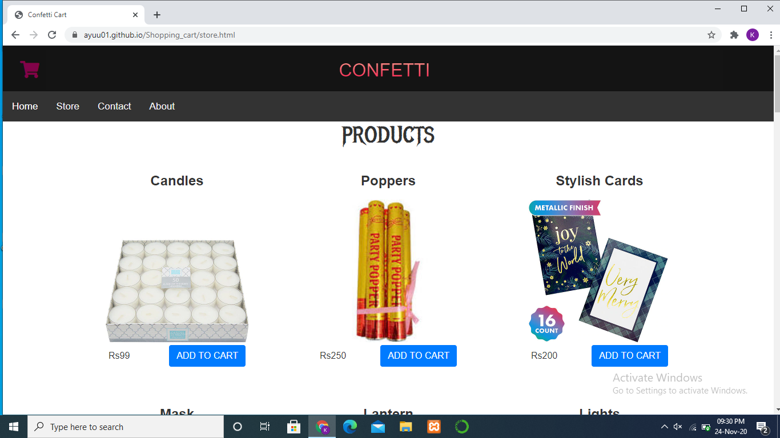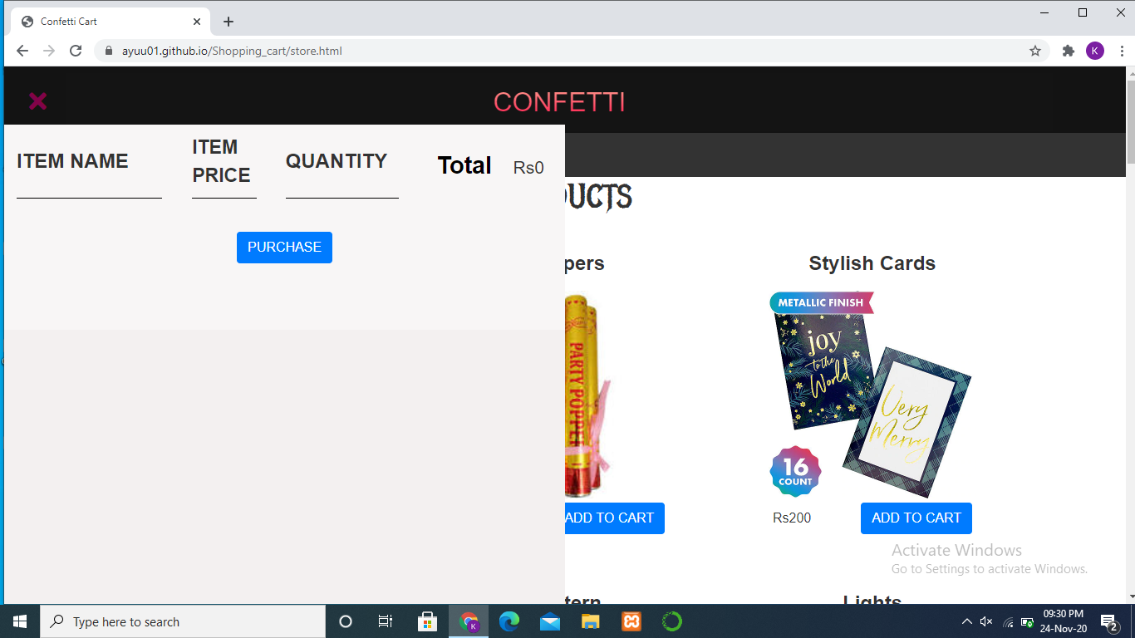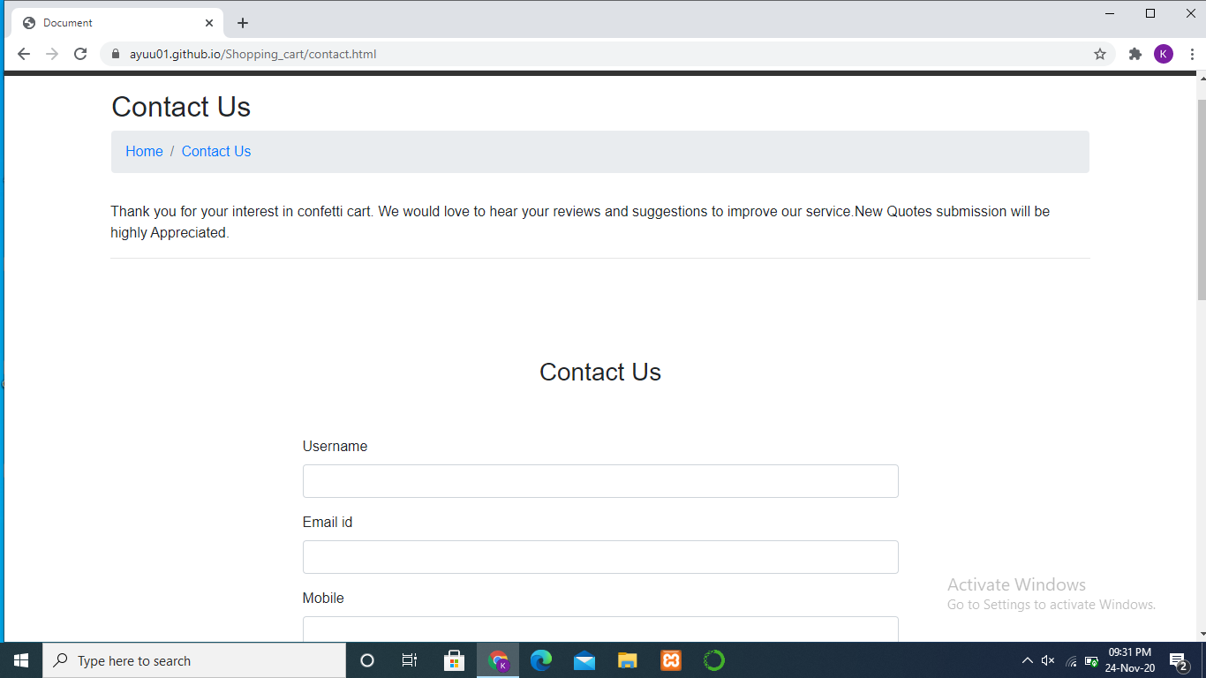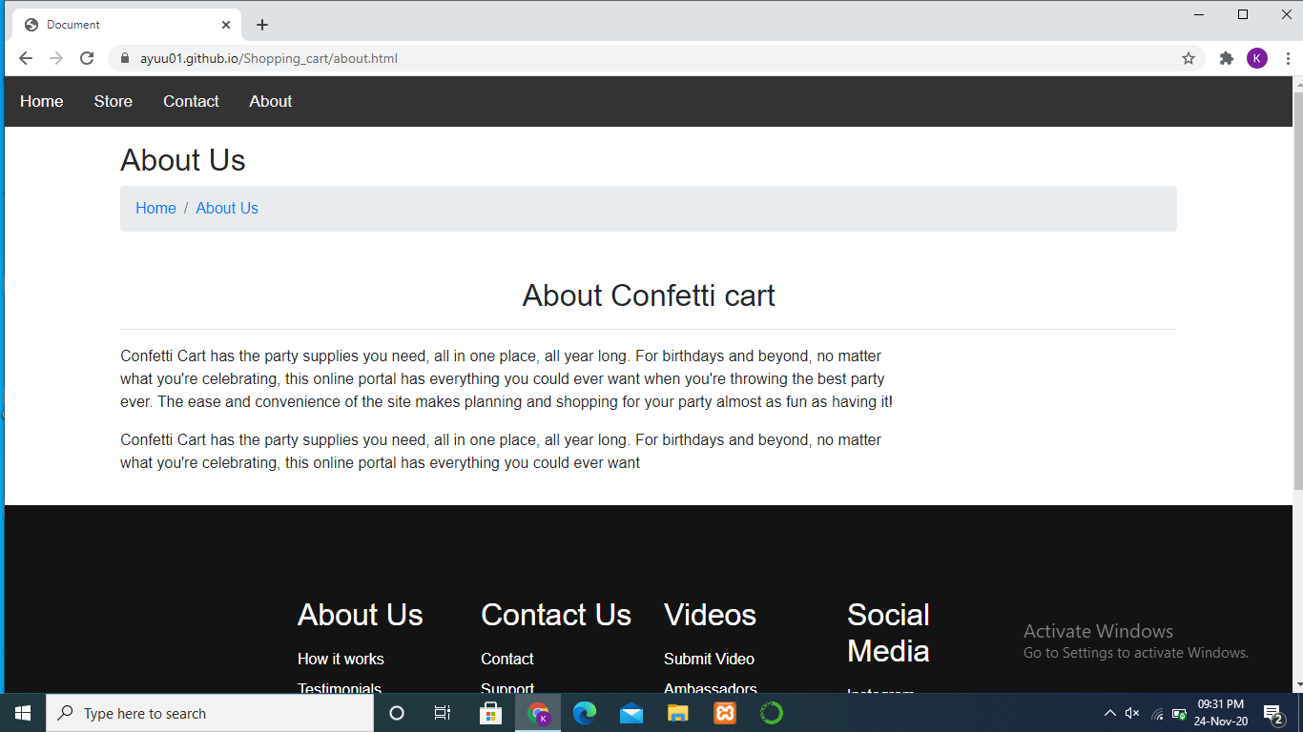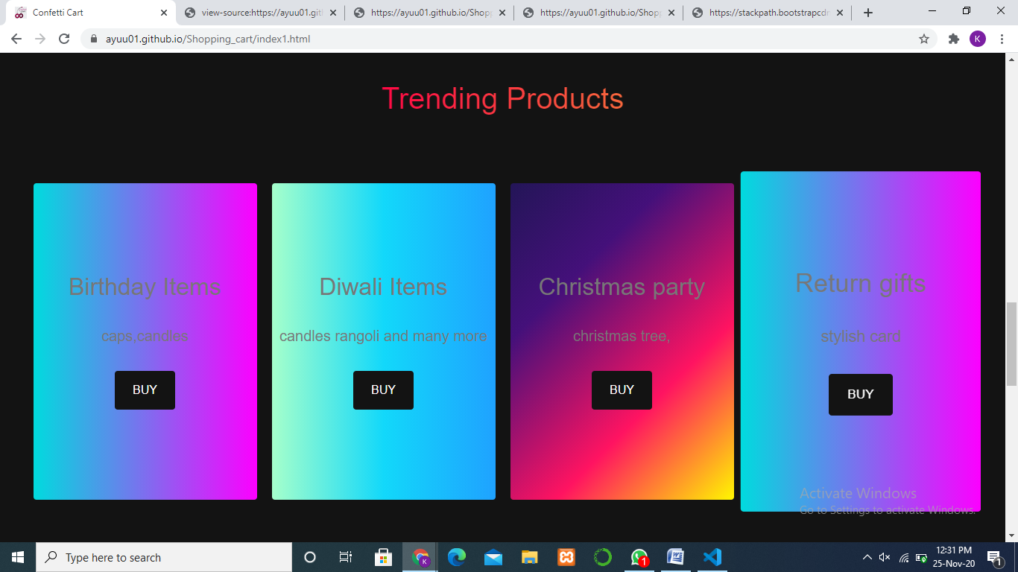

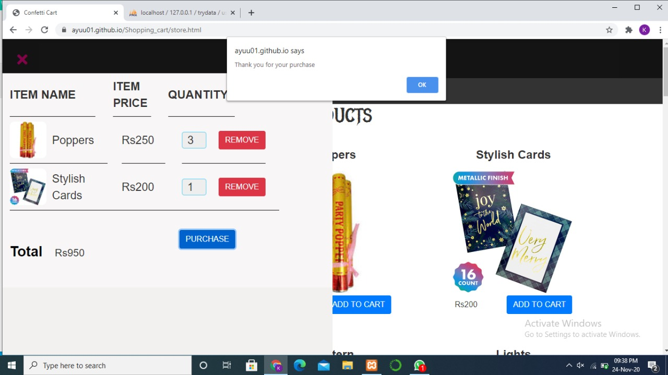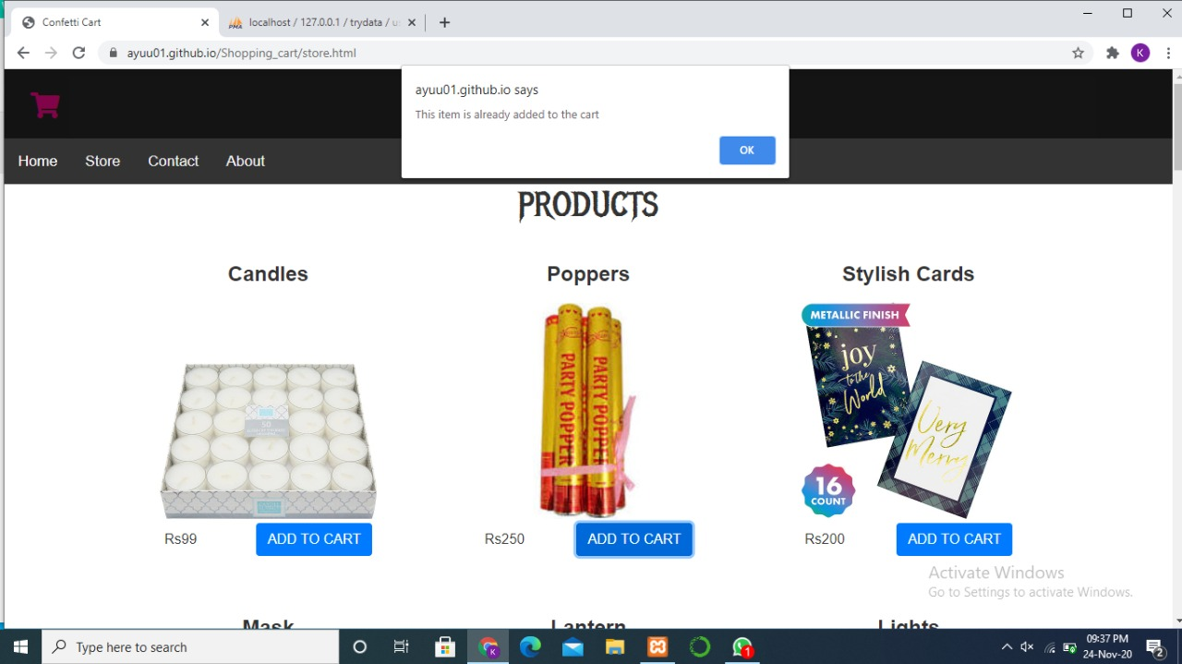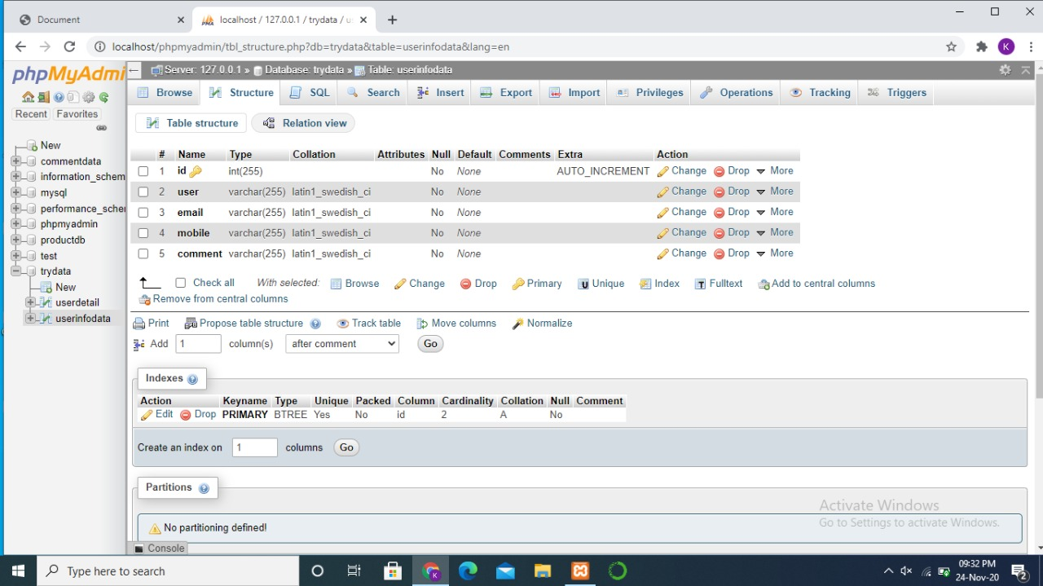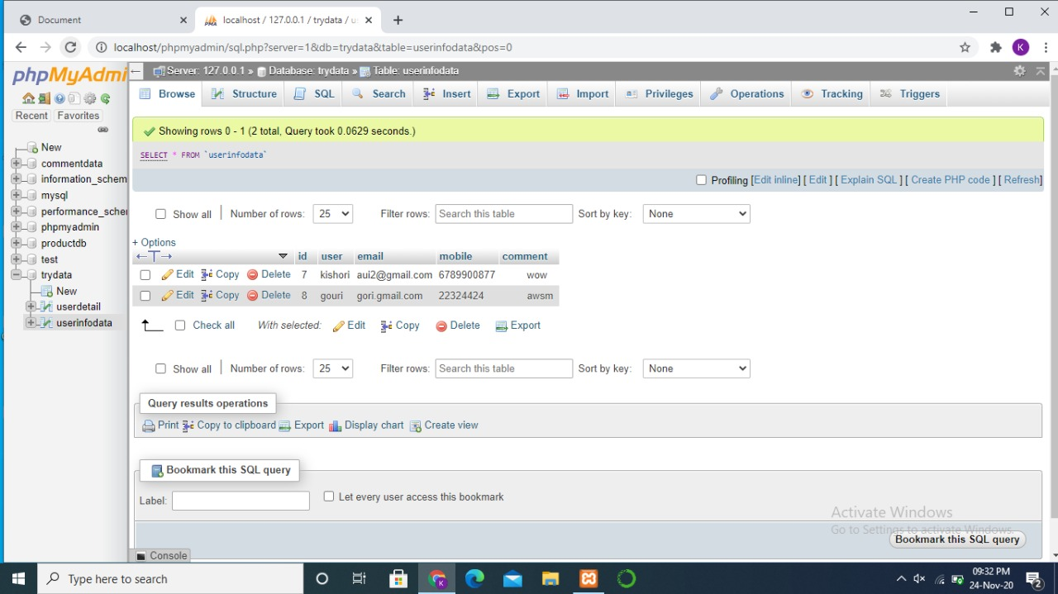

**CODE-**

INDEX FILE:

|  |  |
| --- | --- |
|  | <!DOCTYPE html> |
|  | <html lang="en"> |
|  |  |
|  | <head> |
|  | <meta charset="UTF-8" /> |
|  | <meta name="viewport" content="width=device-width, initial-scale=1.0" /> |
|  | <title>Confetti Cart</title> |
|  |  |
|  |  |
|  | <link rel="stylesheet" href="[styles1.css](https://ayuu01.github.io/Shopping_cart/styles1.css)" /> |
|  | <link rel="stylesheet" href="[light.css](https://ayuu01.github.io/Shopping_cart/light.css)"> |
|  | <link rel="stylesheet" href="[slider.css](https://ayuu01.github.io/Shopping_cart/slider.css)"> |
|  | <link rel="stylesheet" href="[box.css](https://ayuu01.github.io/Shopping_cart/box.css)"> |
|  | <link rel="stylesheet" href="[nav.css](https://ayuu01.github.io/Shopping_cart/nav.css)"> |
|  | <link rel="stylesheet" href="[styles.css](https://ayuu01.github.io/Shopping_cart/styles.css)" /> |
|  | <!--<link rel="stylesheet" href="scrollbar.css">!--> |
|  | <link rel='icon' href="[Images/miniproject_logo (2).jpg](https://ayuu01.github.io/Shopping_cart/Images/miniproject_logo%20(2).jpg)"> |
|  |  |
|  |  |
|  |  |
|  | <link rel="stylesheet" href="<https://use.fontawesome.com/releases/v5.14.0/css/all.css>" |
|  | integrity="sha384-HzLeBuhoNPvSl5KYnjx0BT+WB0QEEqLprO+NBkkk5gbc67FTaL7XIGa2w1L0Xbgc" crossorigin="anonymous" /> |
|  |  |
|  | <link rel="stylesheet" href="<https://stackpath.bootstrapcdn.com/bootstrap/4.5.2/css/bootstrap.min.css>" |
|  | integrity="sha384-JcKb8q3iqJ61gNV9KGb8thSsNjpSL0n8PARn9HuZOnIxN0hoP+VmmDGMN5t9UJ0Z" crossorigin="anonymous"> |
|  |  |
|  | <script src="<https://maxcdn.bootstrapcdn.com/bootstrap/4.5.2/js/bootstrap.min.js>"></script> |
|  |  |
|  |  |
|  | <script src="[app1.js](https://ayuu01.github.io/Shopping_cart/app1.js)"></script> |
|  | <script src="[store.js](https://ayuu01.github.io/Shopping_cart/store.js)" async></script> |
|  |  |
|  |  |
|  |  |
|  | <script src="<https://cdnjs.cloudflare.com/ajax/libs/wow/1.1.2/wow.js>" |
|  | integrity="sha512-Rd5Gf5A6chsunOJte+gKWyECMqkG8MgBYD1u80LOOJBfl6ka9CtatRrD4P0P5Q5V/z/ecvOCSYC8tLoWNrCpPg==" |
|  | crossorigin="anonymous"></script> |
|  |  |
|  | <script> |
|  | function myFunction() { |
|  | var x = document.getElementById("myTopnav"); |
|  | if (x.className === "topnav") { |
|  | x.className += " responsive"; |
|  | } else { |
|  | x.className = "topnav"; |
|  | } |
|  | } |
|  | </script> |
|  | <style> |
|  | * { |
|  | padding: 0; |
|  | margin: 0; |
|  | box-sizing: border-box; |
|  | font-family: Arial, Helvetica, sans-serif; |
|  | } |
|  |  |
|  | .header { |
|  | width: 100%; |
|  | height: 70px; |
|  | background-color: rgb(20, 20, 20); |
|  | display: flex; |
|  | justify-content: center; |
|  | align-items: center; |
|  |  |
|  | } |
|  |  |
|  | .header img { |
|  | width: 70px; |
|  | height: 70px; |
|  | margin-right: 15px; |
|  |  |
|  | } |
|  |  |
|  | .header h1 { |
|  | line-height: 70px; |
|  | color: white; |
|  |  |
|  | } |
|  |  |
|  | .content { |
|  | width: 100%; |
|  | padding: 20px; |
|  | transition: .5s; |
|  | float: right; |
|  | } |
|  |  |
|  | .content img { |
|  | width: 100%; |
|  | max-width: 700px; |
|  | display: block; |
|  | margin: auto; |
|  |  |
|  | } |
|  |  |
|  | .content p { |
|  | text-align: justify; |
|  | margin-top: 15px; |
|  | } |
|  |  |
|  | .sidebar { |
|  | width: 50%; |
|  | height: 100%; |
|  | position: fixed; |
|  | top: 70px; |
|  | background-color: rgb(243, 240, 240); |
|  | margin: 0; |
|  | left: -100%; |
|  | transition: .7s; |
|  | } |
|  |  |
|  |  |
|  |  |
|  |  |
|  | .sidebar a i { |
|  | margin: 10px; |
|  | hover: "pink"; |
|  | } |
|  |  |
|  |  |
|  |  |
|  | .social { |
|  | display: flex; |
|  | justify-content: space-evenly; |
|  | align-items: center; |
|  | font-size: 30px; |
|  | border-bottom: 2px solid rgba(255, 255, 255, 0.1); |
|  | padding: 15px 25px; |
|  | border-top: 2px solid rgba(255, 255, 255, 0.1); |
|  | margin-top: 200px; |
|  | } |
|  |  |
|  | i { |
|  | font-size: 30px; |
|  | color: white; |
|  | } |
|  |  |
|  | .show-btn, |
|  | .hide-btn { |
|  | font-size: 30px; |
|  | color: white; |
|  | position: fixed; |
|  | top: 20px; |
|  | left: 30px; |
|  | transition: .5s; |
|  | position: absolute; |
|  |  |
|  | } |
|  |  |
|  | .hide-btn { |
|  | opacity: 0; |
|  | } |
|  |  |
|  | #chk { |
|  |  |
|  | visibility: hidden; |
|  |  |
|  |  |
|  | } |
|  |  |
|  |  |
|  | #chk:checked~.sidebar { |
|  | left: 0; |
|  | } |
|  |  |
|  | #chk:checked~.show-btn { |
|  | opacity: 0; |
|  | } |
|  |  |
|  | #chk:checked~.hide-btn { |
|  | opacity: 1; |
|  | } |
|  |  |
|  | #chk:checked~.content { |
|  | width: 82%; |
|  | } |
|  |  |
|  | @media(max-width:768px) { |
|  | .sidebar { |
|  | width: 100%; |
|  | text-align: center; |
|  | } |
|  |  |
|  | .header h1 { |
|  | display: none; |
|  | } |
|  | } |
|  | </style> |
|  |  |
|  |  |
|  |  |
|  | <script> |
|  | var wow = new WOW( |
|  | { |
|  | boxClass: 'wow', // animated element css class (default is wow) |
|  | animateClass: 'animated', // animation css class (default is animated) |
|  | offset: 0, // distance to the element when triggering the animation (default is 0) |
|  | mobile: true, // trigger animations on mobile devices (default is true) |
|  | live: true, // act on asynchronously loaded content (default is true) |
|  | callback: function (box) { |
|  | // the callback is fired every time an animation is started |
|  | // the argument that is passed in is the DOM node being animated |
|  | }, |
|  | scrollContainer: null, // optional scroll container selector, otherwise use window, |
|  | resetAnimation: true, // reset animation on end (default is true) |
|  | } |
|  | ); |
|  | wow.init(); |
|  | </script> |
|  |  |
|  | </head> |
|  |  |
|  | <body> |
|  |  |
|  |  |
|  |  |
|  |  |
|  |  |
|  |  |
|  |  |
|  |  |
|  |  |
|  |  |
|  | <!-- Hero Section --> |
|  | <!--<div class="hero" id="home"> |
|  | <div class="hero__container"> |
|  |  |
|  | <div class="Light"> |
|  | <h7> |
|  | <span>C</span> |
|  | <span>o</span> |
|  | <span>n</span> |
|  | <span>f</span> |
|  | <span>e</span> |
|  | <span>t</span> |
|  | <span>t</span> |
|  | <span>i</span> |
|  |  |
|  | <span>C</span> |
|  | <span>a</span> |
|  | <span>r</span> |
|  | <span>t</span> |
|  |  |
|  |  |
|  | </h7> |
|  | </div> |
|  |  |
|  |  |
|  | <p class="hero__description">One Click Picks</p> |
|  | <button class="main__btn"><a href="about.html">Know More</a></button> |
|  | </div> |
|  | </div>--> |
|  |  |
|  | <!--navbar--> |
|  | <div class="topnav" id="myTopnav"> |
|  | <a href="[#](https://ayuu01.github.io/Shopping_cart/index1.html)" class="active">Home</a> |
|  | <a href="[store.html](https://ayuu01.github.io/Shopping_cart/store.html)">Products</a> |
|  | <a href="[contact.html](https://ayuu01.github.io/Shopping_cart/contact.html)">Contact Us</a> |
|  | <a href="[about.html](https://ayuu01.github.io/Shopping_cart/about.html)">About Us</a> |
|  | <a href="javascript:void(0);" class="icon" onclick="myFunction()"> |
|  | <i class="fa fa-bars"></i> |
|  | </a> |
|  | </div> |
|  |  |
|  |  |
|  |  |
|  |  |
|  | <div id="slider"> |
|  | <figure> |
|  |  |
|  | <img src="[Images/banner3.jpg](https://ayuu01.github.io/Shopping_cart/Images/banner3.jpg)" height="600px" width="1340px"> |
|  | <img src="[Images/banner2 (1).png](https://ayuu01.github.io/Shopping_cart/Images/banner2%20(1).png)" height="600px" width="1360px"> |
|  | <img src="[Images/banner4.jpg](https://ayuu01.github.io/Shopping_cart/Images/banner4.jpg)" height="600px" width="1340px"> |
|  | <img src="[Images/banner5.jpg](https://ayuu01.github.io/Shopping_cart/Images/banner5.jpg)" height="600px" width="1400px"> |
|  | </figure> |
|  | </div> |
|  |  |
|  |  |
|  |  |
|  |  |
|  |  |
|  |  |
|  |  |
|  |  |
|  | <marquee direction="left" scrollamount="10" width="auto" onmouseover="this.stop();" "="" onmouseout=" this.start();" |
|  | style="color:rgb(243, 233, 233); background-color: #000; margin: 0px;"> |
|  |  |
|  | <p style="padding-top:10px; font-size: 15px;"> |
|  | Confetti Cart has the party supplies you need, all in one place, all year long. For birthdays |
|  | and |
|  | beyond, no matter what you're celebrating, this online portal has everything you could ever want |
|  | </p> |
|  |  |
|  |  |
|  | </marquee> |
|  |  |
|  |  |
|  | <!-- About Section --> |
|  | <div class="main" id=""> |
|  | <div class="main__container"> |
|  | <div class="main__img--container"> |
|  | <div class="main__img--card"><i class="fas fa-layer-group"></i></div> |
|  | </div> |
|  | <div class="main__content"> |
|  | <h1>About Us</h1> |
|  | <h2>Confetti Cart</h2> |
|  | <p>Click here to know more about our website</p> |
|  | <button class="main__btn"><a href="[about.html](https://ayuu01.github.io/Shopping_cart/about.html)">Click Here</a></button> |
|  | </div> |
|  | </div> |
|  | </div> |
|  | <div class="Boxcontainer"> |
|  |  |
|  |  |
|  | <div class="box"> |
|  | <div class="imgBx"> |
|  | <img src="[./Images/diwali products.jpg](https://ayuu01.github.io/Shopping_cart/Images/diwali%20products.jpg)" alt=""> |
|  | </div> |
|  | <div class="Boxcontent"> |
|  | <h2>Diwali Products <br><span>SpecialPrice </span></h2> |
|  | </div> |
|  | </div> |
|  |  |
|  | <div class="box"> |
|  | <div class="imgBx"> |
|  | <img src="[./Images/bday.jpg](https://ayuu01.github.io/Shopping_cart/Images/bday.jpg)" alt=""> |
|  | </div> |
|  | <div class="Boxcontent"> |
|  | <h2>Birthday<br><span>SpecialPrice </span></h2> |
|  | </div> |
|  | </div> |
|  |  |
|  | <div class="box"> |
|  | <div class="imgBx"> |
|  | <img src="[./Images/christmas (1).jpg](https://ayuu01.github.io/Shopping_cart/Images/christmas%20(1).jpg)" alt=""> |
|  | </div> |
|  | <div class="Boxcontent"> |
|  | <h2>Christmas <br><span>SpecialPrice </span></h2> |
|  | </div> |
|  | </div> |
|  |  |
|  | </div> |
|  |  |
|  |  |
|  |  |
|  | <!-- Services Section --> |
|  | <div class="services" id=""> |
|  | <h1>Trending Products</h1> |
|  | <div class="services__wrapper"> |
|  | <div class="services__card"> |
|  | <h2>Birthday Items</h2> |
|  | <p>caps,candles</p> |
|  | <div class="services__btn"><button>BUY</button></div> |
|  | </div> |
|  | <div class="services__card"> |
|  | <h2>Diwali Items</h2> |
|  | <p>candles rangoli and many more</p> |
|  | <div class="services__btn"><button>BUY</button></div> |
|  | </div> |
|  | <div class="services__card"> |
|  | <h2>Christmas party</h2> |
|  | <p>christmas tree,</p> |
|  | <div class="services__btn"><button>BUY</button></div> |
|  | </div> |
|  | <div class="services__card"> |
|  | <h2>Return gifts</h2> |
|  | <p>stylish card</p> |
|  | <div class="services__btn"><button>BUY</button></div> |
|  | </div> |
|  | </div> |
|  |  |
|  | </div> |
|  | <!--product |
|  | <section class="container content-section"> |
|  | <h2 class="section-header">PRODUCTS</h2> |
|  | <div class="shop-items"> |
|  | <div class="shop-item"> |
|  | <span class="shop-item-title">Candles</span> |
|  | <img class="shop-item-image" src="Images/candle set.png"> |
|  | <div class="shop-item-details"> |
|  | <span class="shop-item-price">Rs99</span> |
|  | <button class="btn btn-primary shop-item-button" type="button">ADD TO CART</button> |
|  | </div> |
|  | </div> |
|  | <div class="shop-item"> |
|  | <span class="shop-item-title">Poppers</span> |
|  | <img class="shop-item-image" src="Images/Golden popper.jpg"> |
|  | <div class="shop-item-details"> |
|  | <span class="shop-item-price">Rs250</span> |
|  | <button class="btn btn-primary shop-item-button" type="button">ADD TO CART</button> |
|  | </div> |
|  | </div> |
|  |  |
|  | <div class="shop-item"> |
|  | <span class="shop-item-title">Stylish Cards</span> |
|  | <img class="shop-item-image" src="Images/card.png"> |
|  | <div class="shop-item-details"> |
|  | <span class="shop-item-price">Rs200</span> |
|  | <button class="btn btn-primary shop-item-button" type="button">ADD TO CART</button> |
|  | </div> |
|  | </div> |
|  |  |
|  | <div class="shop-item"> |
|  | <span class="shop-item-title">Mask</span> |
|  | <img class="shop-item-image" src="Images/masks.png"> |
|  | <div class="shop-item-details"> |
|  | <span class="shop-item-price">Rs399</span> |
|  | <button class="btn btn-primary shop-item-button" type="button">ADD TO CART</button> |
|  | </div> |
|  | </div> |
|  |  |
|  | <div class="shop-item"> |
|  | <span class="shop-item-title">Lantern</span> |
|  | <img class="shop-item-image" src="Images/lantern.png"> |
|  | <div class="shop-item-details"> |
|  | <span class="shop-item-price">Rs349</span> |
|  | <button class="btn btn-primary shop-item-button" type="button">ADD TO CART</button> |
|  | </div> |
|  | </div> |
|  |  |
|  | <div class="shop-item"> |
|  | <span class="shop-item-title">Lights</span> |
|  | <img class="shop-item-image" src="Images/light.png"> |
|  | <div class="shop-item-details"> |
|  | <span class="shop-item-price">Rs169</span> |
|  | <button class="btn btn-primary shop-item-button" type="button">ADD TO CART</button> |
|  | </div> |
|  | </div> |
|  |  |
|  | <div class="shop-item"> |
|  | <span class="shop-item-title">Party Caps</span> |
|  | <img class="shop-item-image" src="Images/bday caps.jpg"> |
|  | <div class="shop-item-details"> |
|  | <span class="shop-item-price">Rs110</span> |
|  | <button class="btn btn-primary shop-item-button" type="button">ADD TO CART</button> |
|  | </div> |
|  | </div> |
|  |  |
|  | <div class="shop-item"> |
|  | <span class="shop-item-title">Balloon</span> |
|  | <img class="shop-item-image" src="Images/bday ballons.png"> |
|  | <div class="shop-item-details"> |
|  | <span class="shop-item-price">Rs149</span> |
|  | <button class="btn btn-primary shop-item-button" type="button">ADD TO CART</button> |
|  | </div> |
|  | </div> |
|  |  |
|  | <div class="shop-item"> |
|  | <span class="shop-item-title">Frills</span> |
|  | <img class="shop-item-image" src="Images/beads.jpg"> |
|  | <div class="shop-item-details"> |
|  | <span class="shop-item-price">Rs110</span> |
|  | <button class="btn btn-primary shop-item-button" type="button">ADD TO CART</button> |
|  | </div> |
|  | </div> |
|  |  |
|  | <div class="shop-item"> |
|  | <span class="shop-item-title">Christmas Tree</span> |
|  | <img class="shop-item-image" src="Images/christmas tree.png"> |
|  | <div class="shop-item-details"> |
|  | <span class="shop-item-price">Rs449</span> |
|  | <button class="btn btn-primary shop-item-button" type="button">ADD TO CART</button> |
|  | </div> |
|  | </div> |
|  |  |
|  | <div class="shop-item"> |
|  | <span class="shop-item-title">Color Lights</span> |
|  | <img class="shop-item-image" src="Images/Color Lights.jpg"> |
|  | <div class="shop-item-details"> |
|  | <span class="shop-item-price">Rs329</span> |
|  | <button class="btn btn-primary shop-item-button" type="button">ADD TO CART</button> |
|  | </div> |
|  | </div> |
|  |  |
|  | <div class="shop-item"> |
|  | <span class="shop-item-title">Diwali Diyas</span> |
|  | <img class="shop-item-image" src="Images/diya.png"> |
|  | <div class="shop-item-details"> |
|  | <span class="shop-item-price">Rs250</span> |
|  | <button class="btn btn-primary shop-item-button" type="button">ADD TO CART</button> |
|  | </div> |
|  | </div> |
|  |  |
|  | <div class="shop-item"> |
|  | <span class="shop-item-title">Multicolor Frills</span> |
|  | <img class="shop-item-image" src="Images/frills.jpg"> |
|  | <div class="shop-item-details"> |
|  | <span class="shop-item-price">Rs250</span> |
|  | <button class="btn btn-primary shop-item-button" type="button">ADD TO CART</button> |
|  | </div> |
|  | </div> |
|  |  |
|  | <div class="shop-item"> |
|  | <span class="shop-item-title">Props</span> |
|  | <img class="shop-item-image" src="Images/props.png"> |
|  | <div class="shop-item-details"> |
|  | <span class="shop-item-price">Rs289</span> |
|  | <button class="btn btn-primary shop-item-button" type="button">ADD TO CART</button> |
|  | </div> |
|  | </div> |
|  |  |
|  | <div class="shop-item"> |
|  | <span class="shop-item-title">Rangoli Stickers Set</span> |
|  | <img class="shop-item-image" src="Images/rangoli sticker.png"> |
|  | <div class="shop-item-details"> |
|  | <span class="shop-item-price">Rs239</span> |
|  | <button class="btn btn-primary shop-item-button" type="button">ADD TO CART</button> |
|  | </div> |
|  | </div> |
|  |  |
|  | <div class="shop-item"> |
|  | <span class="shop-item-title">Star</span> |
|  | <img class="shop-item-image" src="Images/star.png"> |
|  | <div class="shop-item-details"> |
|  | <span class="shop-item-price">Rs89</span> |
|  | <button class="btn btn-primary shop-item-button" type="button">ADD TO CART</button> |
|  | </div> |
|  | </div> |
|  | <div class="shop-item"> |
|  | <span class="shop-item-title">Star Light</span> |
|  | <img class="shop-item-image" src="Images/starLIGHT.png"> |
|  | <div class="shop-item-details"> |
|  | <span class="shop-item-price">Rs349</span> |
|  | <button class="btn btn-primary shop-item-button" type="button">ADD TO CART</button> |
|  | </div> |
|  | </div> |
|  |  |
|  | <div class="shop-item"> |
|  | <span class="shop-item-title">Handicraft Diyas</span> |
|  | <img class="shop-item-image" src="Images/handicraft diya.jpg"> |
|  | <div class="shop-item-details"> |
|  | <span class="shop-item-price">Rs200</span> |
|  | <button class="btn btn-primary shop-item-button" type="button">ADD TO CART</button> |
|  | </div> |
|  | </div> |
|  |  |
|  | <div class="shop-item"> |
|  | <span class="shop-item-title">Party Plate Set</span> |
|  | <img class="shop-item-image" src="Images/plate.png"> |
|  | <div class="shop-item-details"> |
|  | <span class="shop-item-price">Rs399</span> |
|  | <button class="btn btn-primary shop-item-button" type="button">ADD TO CART</button> |
|  | </div> |
|  | </div> |
|  |  |
|  | <div class="shop-item"> |
|  | <span class="shop-item-title">Smiley Balloon</span> |
|  | <img class="shop-item-image" src="Images/smiley ballons.jpg"> |
|  | <div class="shop-item-details"> |
|  | <span class="shop-item-price">Rs250</span> |
|  | <button class="btn btn-primary shop-item-button" type="button">ADD TO CART</button> |
|  | </div> |
|  | </div> |
|  |  |
|  | <div class="shop-item"> |
|  | <span class="shop-item-title">Fairy Lights</span> |
|  | <img class="shop-item-image" src="Images/Golden Lights.jpg"> |
|  | <div class="shop-item-details"> |
|  | <span class="shop-item-price">Rs348</span> |
|  | <button class="btn btn-primary shop-item-button" type="button">ADD TO CART</button> |
|  | </div> |
|  | </div> |
|  |  |
|  | <div class="shop-item"> |
|  | <span class="shop-item-title">Paper Cups Set</span> |
|  | <img class="shop-item-image" src="Images/cups.png"> |
|  | <div class="shop-item-details"> |
|  | <span class="shop-item-price">Rs170</span> |
|  | <button class="btn btn-primary shop-item-button" type="button">ADD TO CART</button> |
|  | </div> |
|  | </div> |
|  |  |
|  | <div class="shop-item"> |
|  | <span class="shop-item-title">Pumpkin Light</span> |
|  | <img class="shop-item-image" src="Images/pumkin.jpg"> |
|  | <div class="shop-item-details"> |
|  | <span class="shop-item-price">Rs459</span> |
|  | <button class="btn btn-primary shop-item-button" type="button">ADD TO CART</button> |
|  | </div> |
|  | </div> |
|  |  |
|  |  |
|  |  |
|  |  |
|  | <div class="shop-item"> |
|  | <span class="shop-item-title">Bow</span> |
|  | <img class="shop-item-image" src="Images/bow.jpg"> |
|  | <div class="shop-item-details"> |
|  | <span class="shop-item-price">Rs120</span> |
|  | <button class="btn btn-primary shop-item-button" type="button">ADD TO CART</button> |
|  | </div> |
|  | </div> |
|  | </div> |
|  | </section> |
|  | <div class="select"> |
|  |  |
|  | </div>--> |
|  |  |
|  |  |
|  | <!-- Cart Section |
|  | <div class="main" id="shopping-cart"> |
|  |  |
|  | <section class="container content-section"> |
|  | <h2 class="section-header">CART</h2> |
|  | <div class="cart-row"> |
|  | <span class="cart-item cart-header cart-column">ITEM</span> |
|  | <span class="cart-price cart-header cart-column">PRICE</span> |
|  | <span class="cart-quantity cart-header cart-column">QUANTITY</span> |
|  | </div> |
|  | <div class="cart-items"> |
|  | </div> |
|  | <div class="cart-total"> |
|  | <strong class="cart-total-title">Total</strong> |
|  | <span class="cart-total-price">$0</span> |
|  | </div> |
|  | <button class="btn btn-primary btn-purchase" type="button">PURCHASE</button> |
|  | </section> |
|  | </div> --> |
|  |  |
|  | <!--contact us--> |
|  | <div class="main__container"> |
|  | <div class="main__content"> |
|  | <h1>Join Our Team</h1> |
|  | <h2>Contact US</h2> |
|  | <p>See what makes us different</p> |
|  | <button class="main__btn"><a href="[contact.html](https://ayuu01.github.io/Shopping_cart/contact.html)">Click Here</a></button> |
|  | </div> |
|  | <div class="main__img--container"> |
|  | <div class="main__img--card" id="card-2"> |
|  | <i class="fas fa-users"></i> |
|  | </div> |
|  | </div> |
|  | </div> |
|  |  |
|  |  |
|  |  |
|  | <!-- Footer Section --> |
|  | <div class="footer__container"> |
|  | <div class="footer__links"> |
|  | <div class="footer__link--wrapper"> |
|  | <div class="footer__link--items"> |
|  | <h2>About Us</h2> |
|  | <a href="">How it works</a> <a href="">Testimonials</a> |
|  | <a href="">Careers</a> <a href="">Terms of Service</a> |
|  | </div> |
|  | <div class="footer__link--items"> |
|  | <h2>Contact Us</h2> |
|  | <a href="">Contact</a> <a href="">Support</a> |
|  | <a href="">Destinations</a> |
|  | </div> |
|  | </div> |
|  | <div class="footer__link--wrapper"> |
|  | <div class="footer__link--items"> |
|  | <h2>Videos</h2> |
|  | <a href="">Submit Video</a> <a href="">Ambassadors</a> |
|  | <a href="">Agency</a> |
|  | </div> |
|  | <div class="footer__link--items"> |
|  | <h2>Social Media</h2> |
|  | <a href="">Instagram</a> <a href="">Facebook</a> |
|  | <a href="">Youtube</a> <a href="">Twitter</a> |
|  | </div> |
|  | </div> |
|  | </div> |
|  | <section class="social__media"> |
|  | <div class="social__media--wrap"> |
|  | <div class="footer__logo"> |
|  | <a href="" id="footer__logo">CONFETTI CART</a> |
|  | </div> |
|  | <p class="website__rights">© CONFETTI CART 2020. All rights reserved</p> |
|  | <div class="social__icons"> |
|  | <a href="" class="social__icon--link" target="_blank"><i class="fab fa-facebook"></i></a> |
|  | <a href="" class="social__icon--link"><i class="fab fa-instagram"></i></a> |
|  | <a href="" class="social__icon--link"><i class="fab fa-youtube"></i></a> |
|  | <a href="" class="social__icon--link"><i class="fab fa-linkedin"></i></a> |
|  | <a href="" class="social__icon--link"><i class="fab fa-twitter"></i></a> |
|  | </div> |
|  | </div> |
|  | </section> |
|  | </div> |
|  |  |
|  | </body> |
|  |  |
|  | </html> |

CSS FILE:

* {

box-sizing: border-box;

margin: 0;

padding: 0;

font-family: 'Kumbh Sans', sans-serif;

scroll-behavior: smooth;

}

.navbar {

background: #131313;

height: 80px;

display: flex;

justify-content: center;

align-items: center;

font-size: 1.2rem;

position: sticky;

top: 0;

z-index: 999;

}

.navbar__container {

display: flex;

justify-content: space-between;

height: 80px;

z-index: 1;

width: 100%;

max-width: 1300px;

margin: 0 auto;

padding: 0 50px;

}

#navbar__logo {

background-color: #ff8177;

background-image: linear-gradient(to top, #ff0844 0%, #ffb199 100%);

background-size: 100%;

-webkit-background-clip: text;

-moz-background-clip: text;

-webkit-text-fill-color: transparent;

-moz-text-fill-color: transparent;

display: flex;

align-items: center;

cursor: pointer;

text-decoration: none;

font-size: 2rem;

}

.navbar__menu {

display: flex;

align-items: center;

list-style: none;

}

.navbar__item {

height: 80px;

}

.navbar__links {

color: #fff;

display: flex;

align-items: center;

justify-content: center;

width: 125px;

text-decoration: none;

height: 100%;

transition: all 0.3s ease;

}

.navbar__btn {

display: flex;

justify-content: center;

align-items: center;

padding: 0 1rem;

width: 100%;

}

.button {

display: flex;

justify-content: center;

align-items: center;

text-decoration: none;

padding: 10px 20px;

height: 100%;

width: 100%;

border: none;

outline: none;

border-radius: 4px;

background: #833ab4;

background: -webkit-linear-gradient(to right, #fcb045, #fd1d1d, #833ab4);

background: linear-gradient(to right, #fcb045, #fd1d1d, #833ab4);

color: #fff;

transition: all 0.3s ease;

}

.navbar__links:hover {

color: #9518fc;

transition: all 0.3s ease;

}

@media screen and (max-width: 960px) {

.navbar__container {

display: flex;

justify-content: space-between;

height: 80px;

z-index: 1;

width: 100%;

max-width: 1300px;

padding: 0;

}

.navbar__menu {

display: grid;

grid-template-columns: auto;

margin: 0;

width: 100%;

position: absolute;

top: -1000px;

opacity: 1;

transition: all 0.5s ease;

z-index: -1;

}

.navbar__menu.active {

background: #131313;

top: 100%;

opacity: 1;

transition: all 0.5s ease;

z-index: 99;

height: 60vh;

font-size: 1.6rem;

}

#navbar__logo {

padding-left: 25px;

}

.navbar__toggle .bar {

width: 25px;

height: 3px;

margin: 5px auto;

transition: all 0.3s ease-in-out;

background: #fff;

}

.navbar__item {

width: 100%;

}

.navbar__links {

text-align: center;

padding: 2rem;

width: 100%;

display: table;

}

.navbar__btn {

padding-bottom: 2rem;

}

.button {

display: flex;

justify-content: center;

align-items: center;

width: 80%;

height: 80px;

margin: 0;

}

#mobile-menu {

position: absolute;

top: 20%;

right: 5%;

transform: translate(5%, 20%);

}

.navbar__toggle .bar {

display: block;

cursor: pointer;

}

#mobile-menu.is-active .bar:nth-child(2) {

opacity: 0;

}

#mobile-menu.is-active .bar:nth-child(1) {

transform: translateY(8px) rotate(45deg);

}

#mobile-menu.is-active .bar:nth-child(3) {

transform: translateY(-8px) rotate(-45deg);

}

}

/* Hero Section */

.hero {

background: #000000;

background: linear-gradient(to right, #161616, #000000);

padding: 200px 0;

margin-top: 0px;

}

.hero__container {

display: flex;

flex-direction: column;

justify-content: center;

align-items: center;

max-width: 1200px;

margin: 0 auto;

height: 90%;

text-align: center;

padding: 30px;

}

.hero__heading {

font-size: 100px;

margin-bottom: 24px;

color: #fff;

}

.hero__heading span {

background: #ee0979; /* fallback for old browsers */

background: -webkit-linear-gradient(

to right,

#ff6a00,

#ee0979

); /* Chrome 10-25, Safari 5.1-6 */

background: linear-gradient(

to right,

#ff6a00,

#ee0979

); /* W3C, IE 10+/ Edge, Firefox 16+, Chrome 26+, Opera 12+, Safari 7+ */

background-size: 100%;

-webkit-background-clip: text;

-moz-background-clip: text;

-webkit-text-fill-color: transparent;

-mo-text-fill-color: transparent;

}

.hero__description {

font-size: 60px;

background: #da22ff; /* fallback for old browsers */

background: -webkit-linear-gradient(

to right,

#9114ff,

#da22ff

); /* Chrome 10-25, Safari 5.1-6 */

background: linear-gradient(

to right,

#8f0eff,

#da22ff

); /* W3C, IE 10+/ Edge, Firefox 16+, Chrome 26+, Opera 12+, Safari 7+ */

background-size: 100%;

-webkit-background-clip: text;

-moz-background-clip: text;

-webkit-text-fill-color: transparent;

-moz-text-fill-color: transparent;

}

.highlight {

border-bottom: 4px solid rgb(132, 0, 255);

}

@media screen and (max-width: 768px) {

.hero__heading {

font-size: 60px;

}

.hero__description {

font-size: 40px;

}

}

/* About Section */

.main {

background-color: rgb(248, 246, 246);

padding: 0;

}

.main__container {

display: grid;

grid-template-columns: 1fr 1fr;

align-items: center;

justify-content: center;

margin: 0 auto;

height: 90%;

z-index: 1;

width: 100%;

max-width: 1300px;

padding: 0 50px;

}

.main__content {

color: #fff;

width: 100%;

}

.main__content h1 {

font-size: 2rem;

background-color: #fe3b6f;

background-image: linear-gradient(to top, #ff087b 0%, #ed1a52 100%);

background-size: 100%;

-webkit-background-clip: text;

-moz-background-clip: text;

-webkit-text-fill-color: transparent;

-moz-text-fill-color: transparent;

text-transform: uppercase;

margin-bottom: 32px;

}

.main__content h2 {

font-size: 4rem;

background: #ff8177; /* fallback for old browsers */

background: -webkit-linear-gradient(

to right,

#9114ff,

#da22ff

); /* Chrome 10-25, Safari 5.1-6 */

background: linear-gradient(

to right,

#8f0eff,

#da22ff

); /* W3C, IE 10+/ Edge, Firefox 16+, Chrome 26+, Opera 12+, Safari 7+ */

background-size: 100%;

-webkit-background-clip: text;

-moz-background-clip: text;

-webkit-text-fill-color: transparent;

-moz-text-fill-color: transparent;

}

.main__content p {

margin-top: 1rem;

font-size: 2rem;

font-weight: 700;

}

.main__btn {

font-size: 1.8rem;

background: #833ab4;

background: -webkit-linear-gradient(to right, #fcb045, #fd1d1d, #833ab4);

background: linear-gradient(to right, #fcb045, #fd1d1d, #833ab4);

padding: 20px 60px;

border: none;

border-radius: 4px;

margin-top: 2rem;

cursor: pointer;

position: relative;

transition: all 0.35s;

outline: none;

}

.main__btn a {

position: relative;

z-index: 2;

color: #fff;

text-decoration: none;

}

.main__btn:after {

position: absolute;

content: '';

top: 0;

left: 0;

width: 0;

height: 100%;

background: #ff1ead;

transition: all 0.35s;

border-radius: 4px;

}

.main__btn:hover {

color: #fff;

}

.main__btn:hover:after {

width: 100%;

}

.main__img--container {

text-align: center;

}

.main__img--card {

margin: 10px;

height: 500px;

width: 500px;

border-radius: 4px;

display: flex;

flex-direction: column;

justify-content: center;

color: #fff;

background-image: linear-gradient(to right, #00dbde 0%, #fc00ff 100%);

}

.fa-layer-group,

.fa-users {

font-size: 14rem;

}

#card-2 {

background: #ff512f;

background: -webkit-linear-gradient(to right, #dd2476, #ff512f);

background: linear-gradient(to right, #dd2476, #ff512f);

}

/* Mobile Responsive */

@media screen and (max-width: 1100px) {

.main__container {

display: grid;

grid-template-columns: 1fr;

align-items: center;

justify-content: center;

width: 100%;

margin: 0 auto;

height: 90%;

}

.main__img--container {

display: flex;

justify-content: center;

}

.main__img--card {

height: 425px;

width: 425px;

}

.main__content {

text-align: center;

margin-bottom: 4rem;

}

.main__content h1 {

font-size: 2.5rem;

margin-top: 2rem;

}

.main__content h2 {

font-size: 3rem;

}

.main__content p {

margin-top: 1rem;

font-size: 1.5rem;

}

}

@media screen and (max-width: 480px) {

.main__img--card {

width: 250px;

height: 250px;

}

.fa-users,

.fa-layer-group {

font-size: 4rem;

}

.main__content h1 {

font-size: 2rem;

margin-top: 3rem;

}

.main__content h2 {

font-size: 2rem;

}

.main__content p {

margin-top: 2rem;

}

.main__btn {

padding: 12px 36px;

margin: 2.5rem 0;

}

}

/* Services Section */

.services {

background: #131313;

display: flex;

flex-direction: column;

justify-content: center;

align-items: center;

height: 100%;

padding: 10rem 0;

}

.services h1 {

background-color: #ff8177;

background-image: linear-gradient(to right, #ff0844 0%, #f7673c 100%);

background-size: 100%;

-webkit-background-clip: text;

-moz-background-clip: text;

-webkit-text-fill-color: transparent;

-moz-text-fill-color: transparent;

margin-bottom: 5rem;

font-size: 2.5rem;

}

.services__wrapper {

display: grid;

grid-template-columns: 1fr 1fr 1fr 1fr;

grid-template-rows: 1fr;

}

.services__card {

margin: 10px;

height: 425px;

width: 300px;

border-radius: 4px;

display: flex;

flex-direction: column;

justify-content: center;

color: #fff;

background-image: linear-gradient(to right, #00dbde 0%, #fc00ff 100%);

transition: 0.3s ease-in;

}

.services__card:nth-child(2) {

background: #1fa2ff; /* fallback for old browsers */

background: -webkit-linear-gradient(

to right,

#a6ffcb,

#12d8fa,

#1fa2ff

); /* Chrome 10-25, Safari 5.1-6 */

background: linear-gradient(

to right,

#a6ffcb,

#12d8fa,

#1fa2ff

); /* W3C, IE 10+/ Edge, Firefox 16+, Chrome 26+, Opera 12+, Safari 7+ */

}

.services__card:nth-child(3) {

background-image: linear-gradient(

-225deg,

#231557 0%,

#44107a 29%,

#ff1361 67%,

#fff800 100%

);

}

.services__card h2 {

text-align: center;

}

.services__card p {

text-align: center;

margin-top: 24px;

font-size: 20px;

}

.services__btn {

display: flex;

justify-content: center;

margin-top: 16px;

}

.services__card button {

color: #fff;

padding: 14px 24px;

border: none;

outline: none;

border-radius: 4px;

background: #131313;

font-size: 1rem;

}

.services__card button:hover {

cursor: pointer;

}

.services__card:hover {

transform: scale(1.075);

transition: 0.3s ease-in;

cursor: pointer;

}

@media screen and (max-width: 1300px) {

.services__wrapper {

grid-template-columns: 1fr 1fr;

}

}

@media screen and (max-width: 768px) {

.services__wrapper {

grid-template-columns: 1fr;

}

}

/* Footer CSS */

.footer__container {

background-color: #131313;

padding: 5rem 0;

display: flex;

flex-direction: column;

justify-content: center;

align-items: center;

}

#footer__logo {

color: #fff;

display: flex;

align-items: center;

cursor: pointer;

text-decoration: none;

font-size: 2rem;

}

.footer__links {

width: 100%;

max-width: 1000px;

display: flex;

justify-content: center;

}

.footer__link--wrapper {

display: flex;

}

.footer__link--items {

display: flex;

flex-direction: column;

align-items: flex-start;

margin: 16px;

text-align: left;

width: 160px;

box-sizing: border-box;

}

.footer__link--items h2 {

margin-bottom: 16px;

color: #fff;

}

.footer__link--items a {

color: #fff;

text-decoration: none;

margin-bottom: 0.5rem;

transition: 0.3 ease-out;

}

.footer__link--items a:hover {

color: #e9e9e9;

transition: 0.3 ease-out;

}

.social__icon--link {

color: #fff;

font-size: 24px;

}

.social__media {

max-width: 1000px;

width: 100%;

}

.social__media--wrap {

display: flex;

justify-content: space-between;

align-items: center;

width: 90%;

max-width: 1000px;

margin: 40px auto 0 auto;

}

.social__icons {

display: flex;

justify-content: space-between;

align-items: center;

width: 240px;

}

.website__rights {

color: #fff;

}

@media screen and (max-width: 820px) {

.footer__links {

padding-top: 2rem;

}

#footer__logo {

margin-bottom: 2rem;

}

.website__rights {

margin-bottom: 2rem;

}

.footer__link--wrapper {

flex-direction: column;

}

.social__media--wrap {

flex-direction: column;

}

}

@media screen and (max-width: 480px) {

.footer__link--items {

margin: 0;

padding: 10px;

width: 100%;

}

}

JAVASCRIPT FILE –CART

if (document.readyState == 'loading') {

document.addEventListener('DOMContentLoaded', ready)

} else {

ready()

}

function ready() {

var removeCartItemButtons = document.getElementsByClassName('btn-danger')

for (var i = 0; i < removeCartItemButtons.length; i++) {

var button = removeCartItemButtons[i]

button.addEventListener('click', removeCartItem)

}

var quantityInputs = document.getElementsByClassName('cart-quantity-input')

for (var i = 0; i < quantityInputs.length; i++) {

var input = quantityInputs[i]

input.addEventListener('change', quantityChanged)

}

var addToCartButtons = document.getElementsByClassName('shop-item-button')

for (var i = 0; i < addToCartButtons.length; i++) {

var button = addToCartButtons[i]

button.addEventListener('click', addToCartClicked)

}

document.getElementsByClassName('btn-purchase')[0].addEventListener('click', purchaseClicked)

}

function purchaseClicked() {

alert('Thank you for your purchase')

var cartItems = document.getElementsByClassName('cart-items')[0]

while (cartItems.hasChildNodes()) {

cartItems.removeChild(cartItems.firstChild)

}

updateCartTotal()

}

function removeCartItem(event) {

var buttonClicked = event.target

buttonClicked.parentElement.parentElement.remove()

updateCartTotal()

}

function quantityChanged(event) {

var input = event.target

if (isNaN(input.value) || input.value <= 0) {

input.value = 1

}

updateCartTotal()

}

function addToCartClicked(event) {

var button = event.target

var shopItem = button.parentElement.parentElement

var title = shopItem.getElementsByClassName('shop-item-title')[0].innerText

var price = shopItem.getElementsByClassName('shop-item-price')[0].innerText

var imageSrc = shopItem.getElementsByClassName('shop-item-image')[0].src

addItemToCart(title, price, imageSrc)

updateCartTotal()

}

function addItemToCart(title, price, imageSrc) {

var cartRow = document.createElement('div')

cartRow.classList.add('cart-row')

var cartItems = document.getElementsByClassName('cart-items')[0]

var cartItemNames = cartItems.getElementsByClassName('cart-item-title')

for (var i = 0; i < cartItemNames.length; i++) {

if (cartItemNames[i].innerText == title) {

alert('This item is already added to the cart')

return

}

else{

alert('This item is added to the cart')

}

}

var cartRowContents = `

<div class="cart-item cart-column">

<img class="cart-item-image" src="${imageSrc}" width="100" height="100">

<span class="cart-item-title">${title}</span>

</div>

<span class="cart-price cart-column">${price}</span>

<div class="cart-quantity cart-column">

<input class="cart-quantity-input" type="number" value="1">

<button class="btn btn-danger" type="button">REMOVE</button>

</div>`

cartRow.innerHTML = cartRowContents

cartItems.append(cartRow)

cartRow.getElementsByClassName('btn-danger')[0].addEventListener('click', removeCartItem)

cartRow.getElementsByClassName('cart-quantity-input')[0].addEventListener('change', quantityChanged)

}

function updateCartTotal() {

var cartItemContainer = document.getElementsByClassName('cart-items')[0]

var cartRows = cartItemContainer.getElementsByClassName('cart-row')

var total = 0

for (var i = 0; i < cartRows.length; i++) {

var cartRow = cartRows[i]

var priceElement = cartRow.getElementsByClassName('cart-price')[0]

var quantityElement = cartRow.getElementsByClassName('cart-quantity-input')[0]

var price = parseFloat(priceElement.innerText.replace('Rs', ''))

var quantity = quantityElement.value

total = total + (price * quantity)

}

total = Math.round(total * 100) / 100

document.getElementsByClassName('cart-total-price')[0].innerText = 'Rs' + total

}

**REFERENCES**

* [www.w3schools.com](http://www.w3schools.com)
* [www.nodejs.org](http://www.nodejs.org)
* [www.monogodb.com](http://www.monogodb.com)
* [www.youtube.com](http://www.youtube.com)
* [www.npmjs.com](http://www.npmjs.com)
* [www.bootstrap.com](http://www.bootstrap.com)
* [www.stackoverflow.com](http://www.stackoverflow.com)
* [www.googlefonts.com](http://www.googlefonts.com)